Exercise 05: Making a medical questionnaire (4) - Adding additional field types

* Create a field to record the description of the symptoms.

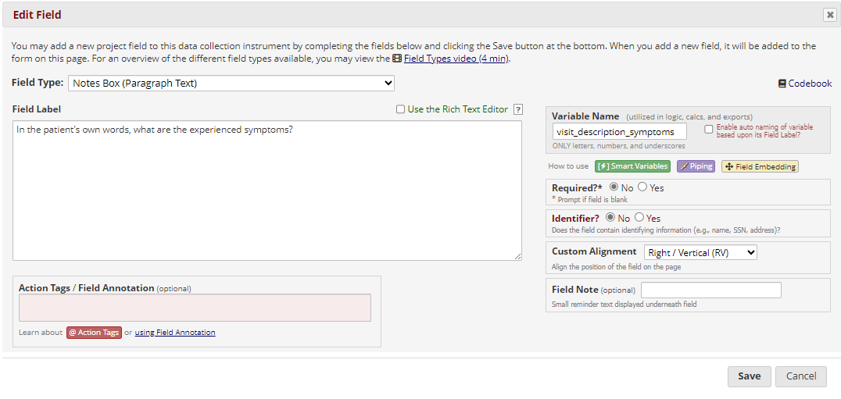

* Create a matrix of fields to evaluate the severity of symptoms:

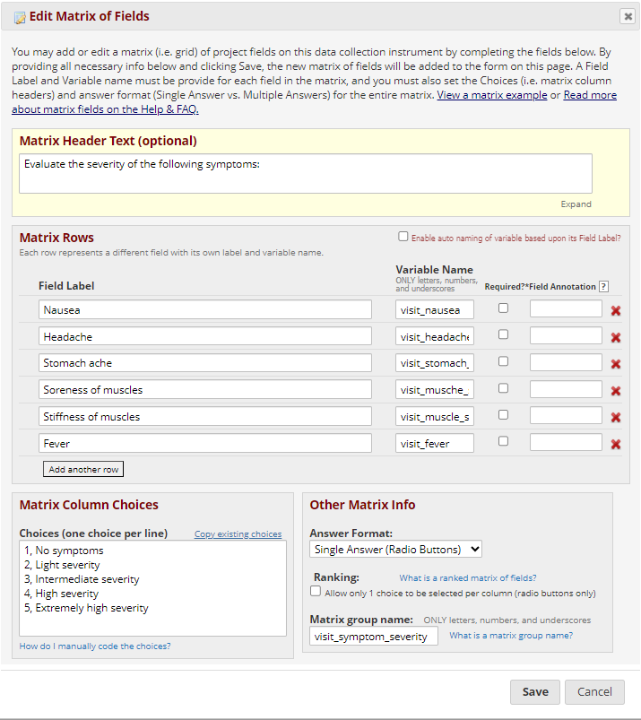

* Create a field where the prescribed medicine is indicated:

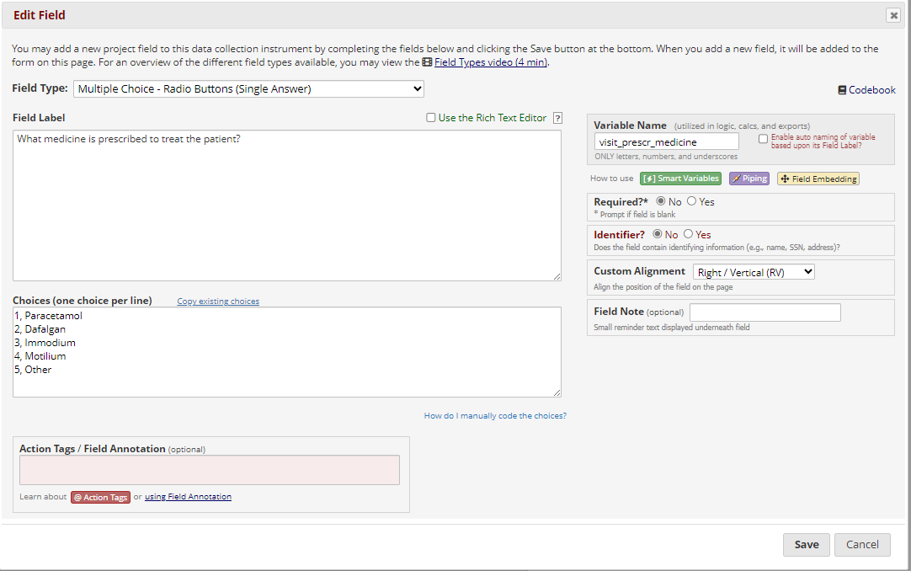

* Create a field to record the dosage of the medication:

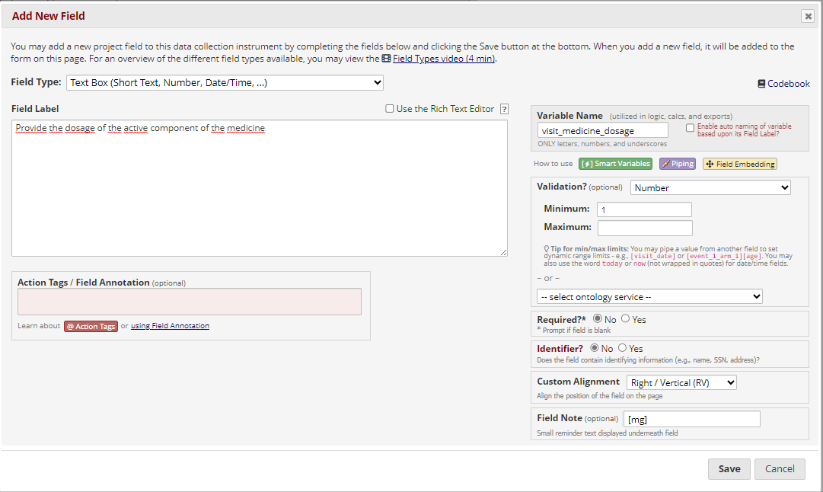

* Create a field to record the frequency of the medication:

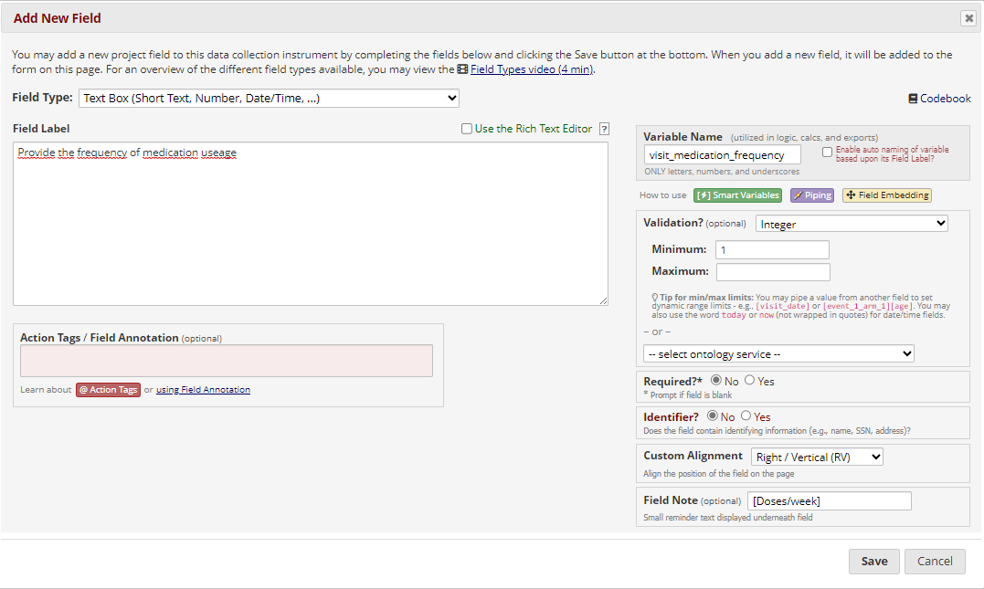

* Create a new section in the doctor form:

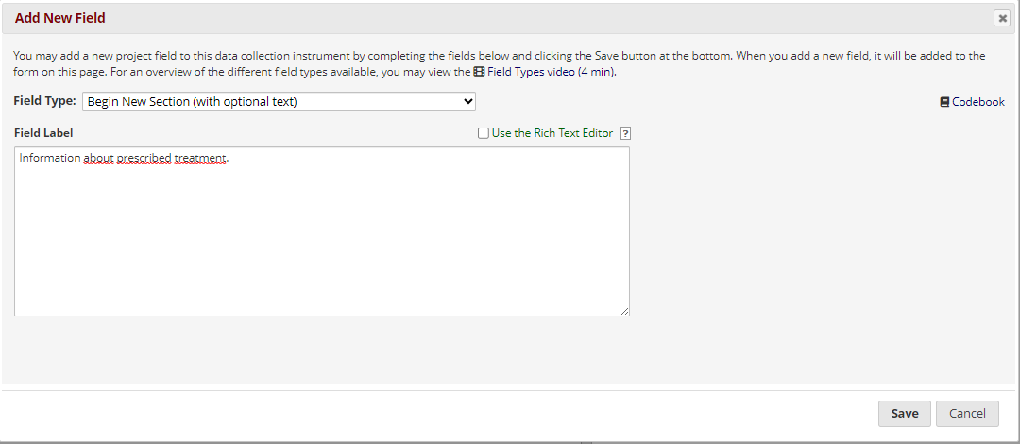

* Create a new instrument called “Health assessment form”

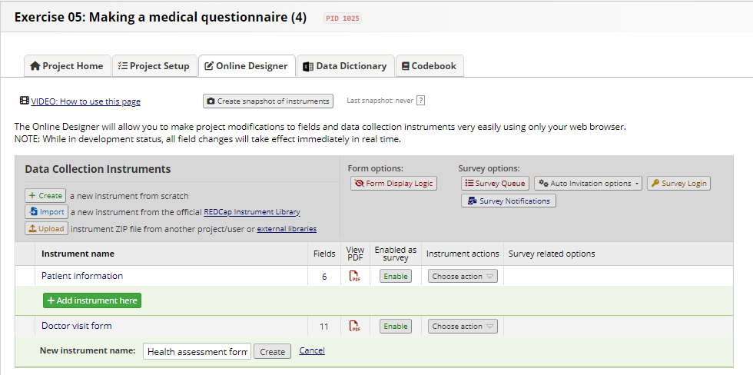

* Create a slider field to inquire about overall health.

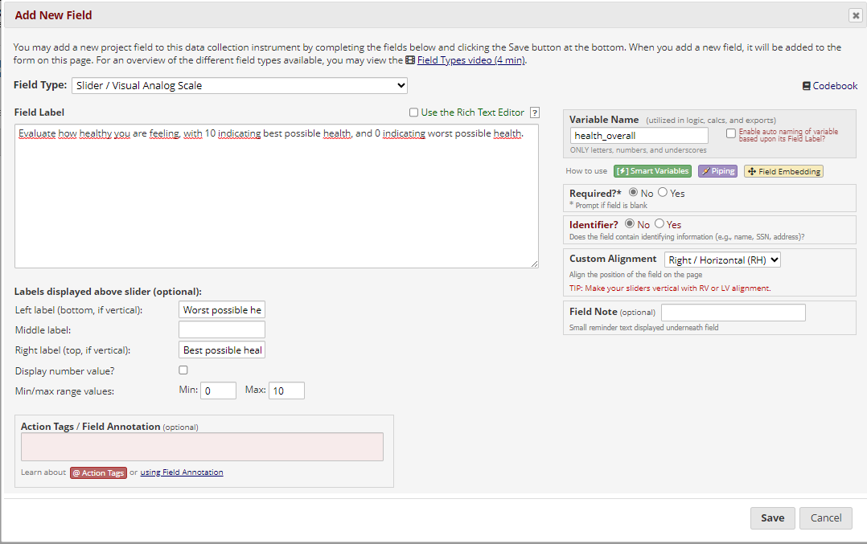

* Create a field to ask if the patient feels that the medicine is helping them

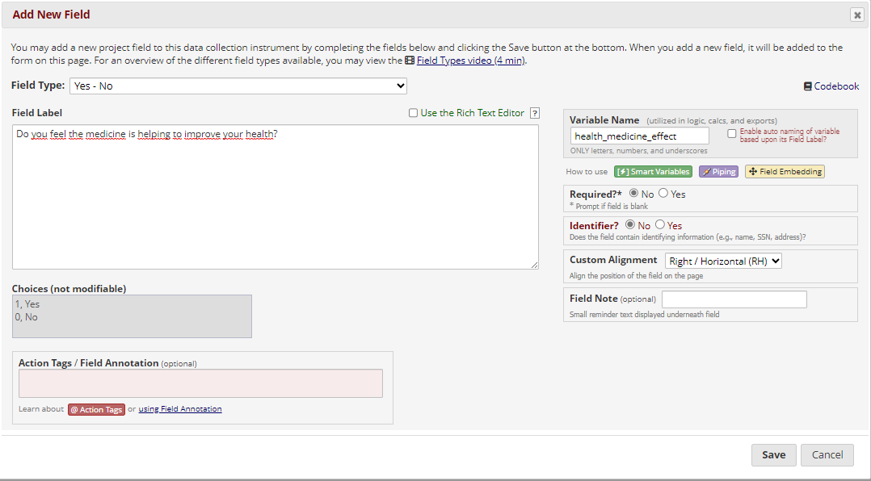

* Create a field to record side effects that patients may experience:

